Máquinas de Turing

1. Reconocedor de palindromes

$$M=(\left\{q_{0},q_{1}, q_{2}, q_{3}, q_{4}, q_{5}, q_{6}, q_{7}, q_{8}\right\},\left\{a,b,c\right\},\left\{X,Y,Z,B\right\},σ,q_{0},B,q_{8})$$

|  |  |  |  |  |  |  |  |
| --- | --- | --- | --- | --- | --- | --- | --- |
|  | a | b | c | X | Y | Z | B |
| $$q_{0}$$ | ( $q_{1}, X, R)$ | ( $q_{3}, Y, R)$ | ( $q_{5}, Z, R)$ | ( $q_{8}, X, R)$ | ( $q_{8}, Y, R)$ | ( $q_{8}, Z, R)$ |  |
| $$q_{1}$$ | ( $q_{1}, a, R)$ | ( $q_{1}, b, R)$ | ( $q_{1}, c, R)$ | ( $q_{2}, X, L)$ | ( $q_{2}, Y, L)$ | ( $q_{2}, Z, L)$ | ( $q_{2}, B, L)$ |
| $$q_{2}$$ | ( $q_{6}, X, L)$ |  |  | ( $q_{8}, X, R)$ |  |  |  |
| $$q_{3}$$ | ( $q_{3}, a, R)$ | ( $q_{3}, b, R)$ | ( $q_{3}, c, R)$ | ( $q_{4}, X, L)$ | ( $q_{4}, Y, L)$ | ( $q_{4}, Z, L)$ | ( $q_{4}, B, L)$ |
| $$q_{4}$$ |  | ( $q_{6}, Y, L)$ |  |  | ( $q_{8}, Y, L)$ |  |  |
| $$q_{5}$$ | ( $q_{5}, a, R)$ | ( $q_{5}, b, R)$ | ( $q_{5}, c, R)$ | ( $q_{7}, X, L)$ | ( $q_{7}, Y, L)$ | ( $q_{7}, Z, L)$ | ( $q_{7}, B, L)$ |
| $$q_{7}$$ |  |  | ( $q_{6}, Z, L)$ |  |  | ( $q_{8}, Z, R)$ |  |
| $$q_{6}$$ | ( $q_{6}, a, L)$ | ( $q_{6}, b, L)$ | ( $q_{6}, c, L)$ | ( $q_{0}, X, R)$ | ( $q_{0}, Y, R)$ | ( $q_{0}, Z, R)$ |  |
| $$q_{8}$$ |  |  |  |  |  |  |  |

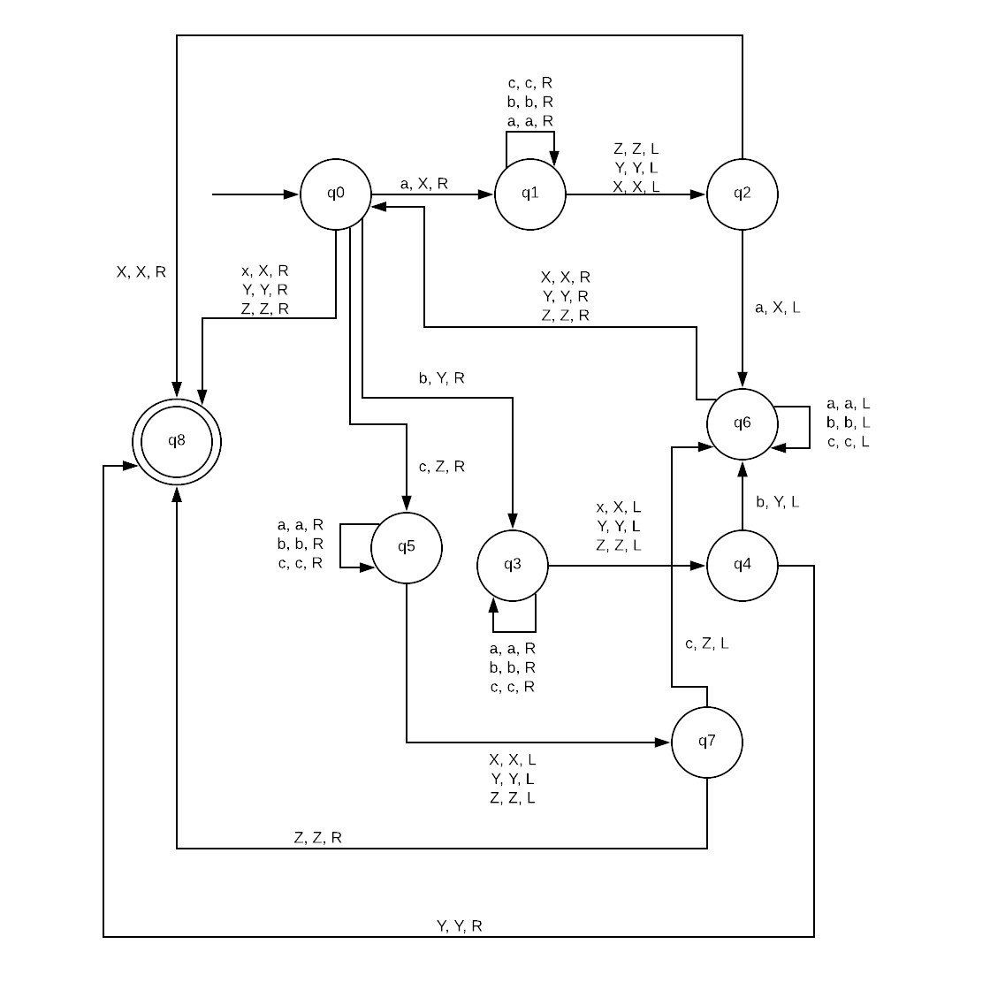

1. Copia de patrones

$$M=(\left\{q0, q1, q2, q3, q4, q5\right\}, \left\{a, b, c\right\}, \left\{X, Y, Z, B\right\}, σ, q0, B, q5)$$

|  |  |  |  |  |  |  |  |
| --- | --- | --- | --- | --- | --- | --- | --- |
|  | a | b | c | X | Y | Z | B |
| q0 | q1, X, R | q2, Y, R | q3, Z, R | q0, X, R | q0, Y, R | q0, Z, R | q5, B, L |
| q1 | q1, a, R | q1, b, R | q1, c, R | q1, X, R | q1, Y, R | q1, Z, R | q4, X, L |
| q2 | q2, a, R | q2, b, R | q2, c, R | q2, X, R | q2, Y, R | q2, Z, R | q4, Y, L |
| q3 | q3, a, R | q3, b, R | q3, c, R | q3, X, R | q3, Y, R | q3, Z, R | q4, Z, L |
| q4 | q4, a, L | q4, b, L | q4, c, L | q4, X, L | q4, Y, L | q4, Z, L | q0, B, R |
| q5 |  |  |  | q5, a, L | q5, b, L | q5, c, L |  |

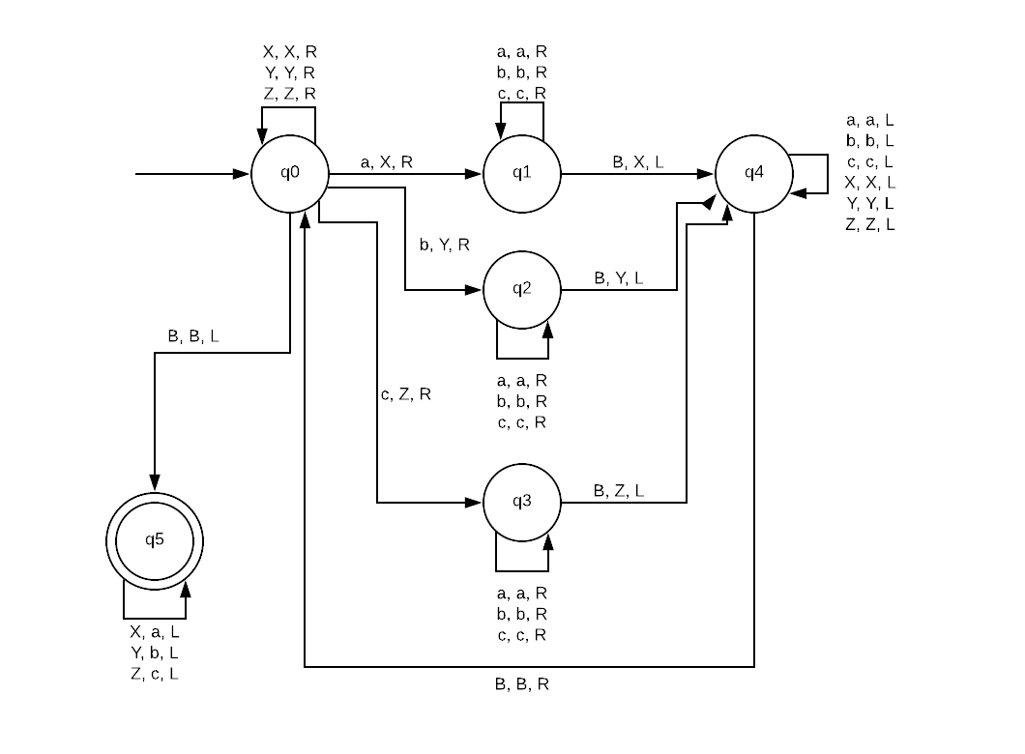

X, X, R

Y, Y, R

Z, Z, R

X, X, R

Y, Y, R

Z, Z, R

X, X, R

Y, Y, R

Z, Z, R

1. Suma Unaria

$$M=(\left\{q0, q1, q2, q3, q4\right\}, \left\{u, +, =\right\}, \left\{X, B\right\}, σ, q0, B, q4)$$

|  |  |  |  |  |  |
| --- | --- | --- | --- | --- | --- |
|  | u | + | = | B | X |
| q0 | q1, X, R | q0, + , R | q4, =, R |  |  |
| q1 | q1, u, R | q1, +, R | q2, =, R |  |  |
| q2 | q2, u, R |  |  | q3, u, L |  |
| q3 | q3, u, L | q3, +, L | q3, =, L |  | q0, u, R |
| q4 |  |  |  |  |  |

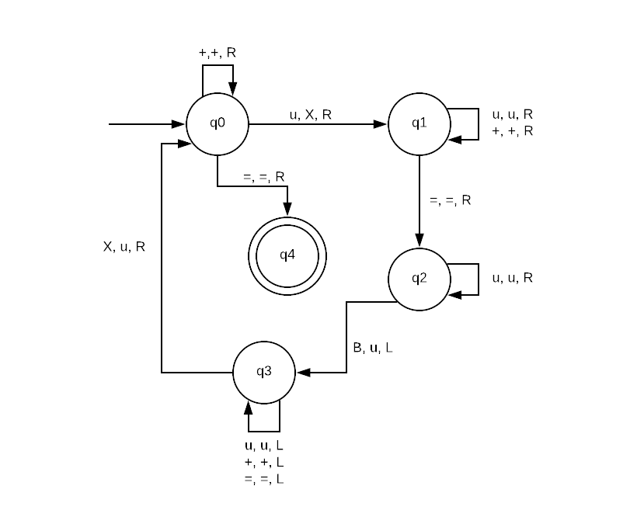

1. Resta Unaria

$$M=(\left\{q0, q1, q2, q3, q4, q5, q6, q7, q8\right\}, \left\{u, -, =\right\}, \left\{X, B\right\}, σ, q0, B, q8)$$

|  |  |  |  |  |  |
| --- | --- | --- | --- | --- | --- |
|  | u | - | = | B | X |
| q0 | q1, X, R | q4, -, R |  |  |  |
| q1 | q1, u, R | q1, -, R | q2, =, R |  |  |
| q2 | q2, u, R |  |  | q3, u, L |  |
| q3 | q3, u, L | q3, -, L | q3, =, L |  | q0, u, R |
| q4 | q5, X, R |  | q8, =, L |  |  |
| q5 | q5, u, R |  | q5, =, R | q6, B, L |  |
| q6 | q7, B, L |  |  |  |  |
| q7 | q7, u, L |  | q7, =, L |  | q4, u, R |
| q8 |  |  |  |  |  |

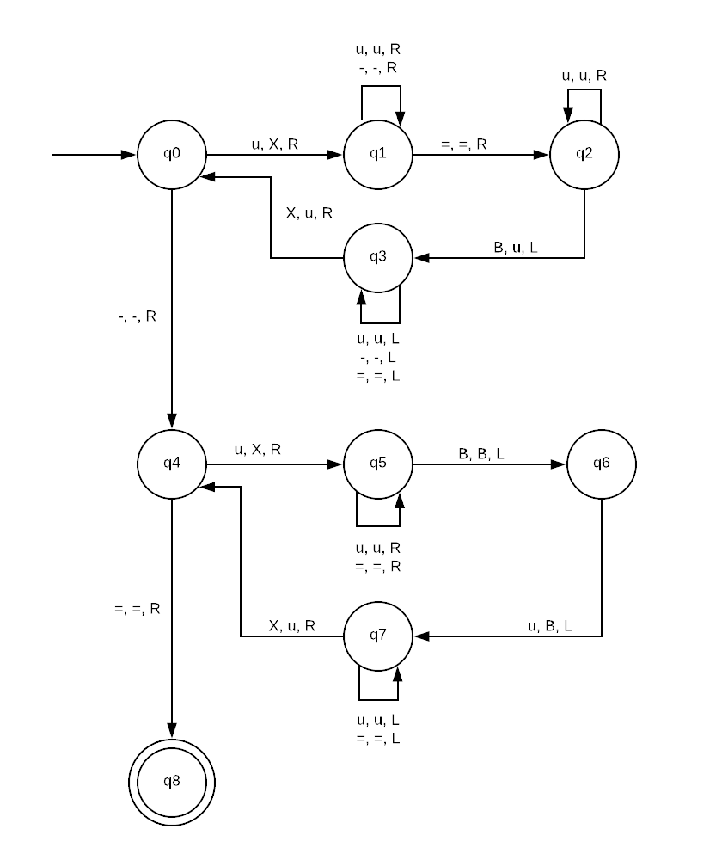

1. Multiplicacion Unaria

$$M=(\left\{q0, q1, q2, q3, q4, q5, q6, q7, q8, q9, q10, q11, q12\right\}, \left\{u, *, =\right\}, \left\{X, Y, B\right\}, σ, q0, B, q12)$$

|  |  |  |  |  |  |  |
| --- | --- | --- | --- | --- | --- | --- |
|  | u | * | = | B | X | Y |
| q0 | q1, X, R |  |  |  |  |  |
| q1 | q1, u, R | q2, *, R |  |  |  |  |
| q2 | q3, Y, R |  | q11, =, L |  |  | q2, Y, R |
| q3 | q3, u, R |  | q4, =, R |  |  |  |
| q4 | q4, u, R |  |  | q5, u, L |  |  |
| q5 | q5, u, L | q5, *, L | q5, =, L |  | q6, u, R | q5, Y, L |
| q6 | q7, X, R | q10, *, L |  |  |  |  |
| q7 | q7, u, R | q7, *, R | q8, =, R |  |  | q7, Y, L |
| q8 | q8, u, R |  |  | q9, u, L |  |  |
| q9 | q9, u, L | q9, *, L | q9, =, L |  | q6, u, R |  |
| q10 | q10, u, L |  |  | q0, B, R |  |  |
| q11 |  | q12, *, L |  |  |  | q11, u, L |
| q12 | q12, u, L |  |  |  | q12, u, L |  |

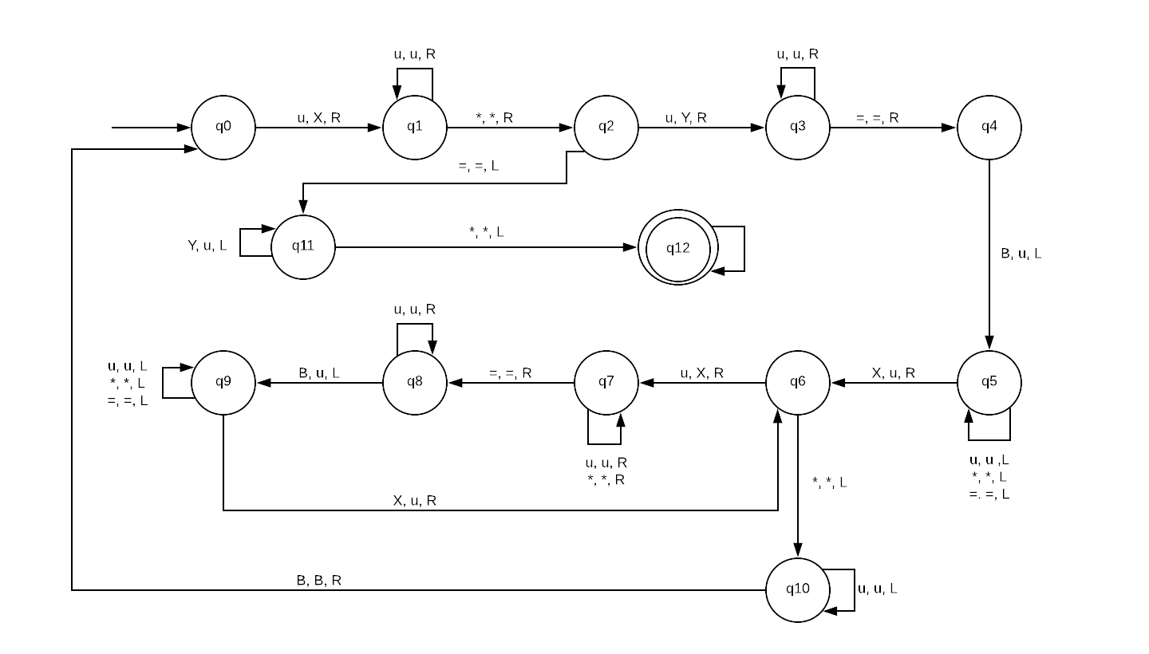

Y, Y, L

Y, Y, L

u, u, L

X, u, L